Civil war in Liberia

UNSC Resolution: | 972
Date of adoption: | 13-Jan-1995
Operative paragraph: | 7
Demand number: | 972,0711

Sarah-Myriam Martin-Brûlé

Wording of demand

strictly respect the status of ECOMOG and UNOMIL personnel, and those of organizations and personnel delivering humanitarian assistance throughout Liberia and further demands that these factions facilitate such deliveries and that they strictly abide by applicable rules of international humanitarian law

List of addressees of the demand

National Patriotic Front of Liberia, Government of Liberia, Central Revolutionary Council of the National Patriotic Front of Liberia, Lola Defence Force, Liberian National Conference, Liberian Peace Council, United Liberation Movement of Liberia for Democracy - Krahn, United Liberation Movement of Liberia for Democracy - Mandingo

Short-term compliance

Description of the addressee(s)’ conduct

The Secretary-General further reported that the military situation in Liberia had remained unstable. Hostilities had spread to over 80 per cent of the country, causing massive population displacement. The inability of ECOMOG to deploy troops along the borders, in accordance with the Cotonou Agreement, had been a factor in the continuous breach of the arms embargo. ECOMOG was deployed in less than 15 per cent of the country, while factions were continuing to acquire arms across the borders and from sources within Liberia. The Secretary-General expressed concern that that situation would have serious consequences for stability in the subregion. He called on the States members of ECOWAS to adhere strictly to the arms embargo and to renew their commitment to the principles of collective security in ensuring that the Liberian crisis was brought to an end.
http://www.un.org/fr/sc/repertoire/93-95/CHAPTER%208/AFRICA/item%2005-%20Liberia.pdf

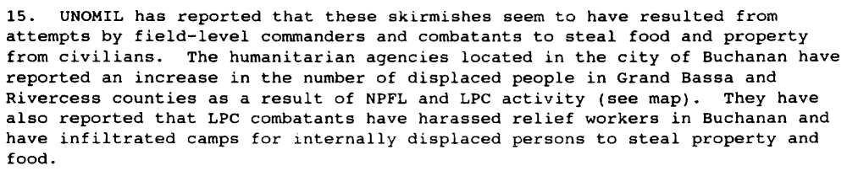
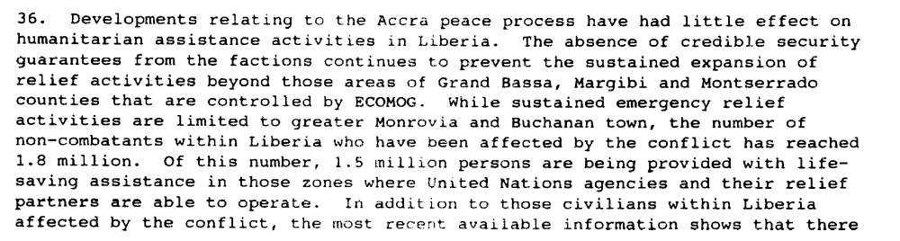
S/1995/158 (24 February 1995)

Assessment

Short-term compliance
X No or marginal compliance (1) | Medium low compliance (2) | Medium high compliance (3) | Full or almost full compliance (4)

Considerations underlying the assessment

The demand addressees did not strictly respect the status of ECOMOG and UNOMIL personnel, and those of organizations and personnel delivering humanitarian assistance throughout Liberia. The factions impeded the deliveries and that they violated applicable rules of international humanitarian law.

Medium-term compliance

Description of the addressee(s)’ conduct

“On 28 December 1995, ULIMO-J combatants attacked ECOMOG troops in the Bomi County town of Tubmanburg, killing sixteen Nigerian peacekeepers, wounding seventy-eight others, and capturing some of ECOMOG’s heavy weapons and other equipment. IN the fighting, ULIMO-J used civilians seeking refuge in a hospital as human shield in a bid to defend Tubmanburg. (…) there were civilian casualties.” (Adebajo 2002: P. 185)

“Third battle in Monrovia (…) the NPFL fighters called the offensive Operation Pay Yourself, the last great attempt to loot ‘as form of compensation for the combatants who have fought for several years without any benefit from theirleaders’. At least 2000 people were killed in a few days of fighting. Accoding to a UN assessment, the UN and its agencies lost a total of 322 vehicles worth some 4.9 million, while international NGOs lost a further 167 vehicles worth 3,2 million, stolen by the various factions and often sold by the fithers to Ecomog for export. ‘ (Ellis 1999, p. 108).

“By the end of 1995, following some initial progress in the implementation of the peace agreements and improvement in the security and humanitarian conditions in the country, the situation in Liberia began to take another turn for the worse. The implementation of the Abuja Agreement was behind schedule. The critical aspects of the Agreement, disarmament and demobilization, did not begin at the time foreseen. There were serious violations of the ceasefire. These violations included intermittent fighting between Alhaji Kromah's forces (ULIMO-K) and Roosevelt Johnson's forces (ULIMO-J). Fighting also occurred between LPC and NPFL and between NPFL and ULIMO-K. There were also delays in deploying ECOMOG personnel and equipment throughout the country. At the end of December 1995, heavy fighting broke out at Tubmanburg as a result of attacks on ECOMOG by ULIMO-J troops. Casualties were suffered by the combatants and by the civilian population.”
“In this volatile atmosphere, following confrontations between rival groups within ULIMO-J, the transitional government, on 23 March, issued a warrant for the arrest of General Roosevelt Johnson, accusing him of murder. On 6 April, the Rapid Reaction Unit of the national police, backed up by the forces of NPFL and ULIMO-K, attempted to arrest him forcibly. They were attacked by General Johnson's forces, supported by fighters from AFL.”
“The fighting was accompanied by the complete breakdown of law and order in Monrovia. Fighters from all factions systematically looted the commercial district as well as United Nations offices and warehouses. Houses were broken into, buildings were set on fire and vehicles were commandeered.”
http://www.un.org/Depts/dpko/dpko/co_mission/unomilFT.htm#DECEMBER

Assessment

Medium-term compliance
X No or marginal compliance (1) | Medium low compliance (2) | Medium high compliance (3) | Full or almost full compliance (4)

Considerations underlying the assessment

Within the two years following the adoption of the agreement, the demand addressees did not strictly respect the status of ECOMOG and UNOMIL personnel, and those of organizations and personnel delivering humanitarian assistance throughout Liberia. The factions impeded the deliveries and that they violated applicable rules of international humanitarian law.

Depth of demand

Assessment

Level of depth of demand
X Low depth of demand (1) | Medium depth of demand (2) | High depth of demand (3)

Considerations underlying the assessment

At that stage in the conflict, compliance with this demand neither put the survival of the demand addressees at a significant risk nor did it impact its chance to attain victory in the civil war or to win power in the aftermath.

Level of confidence about coding decisions

Level of confidence about coding decision
Extremely high | High | X Moderate

Comments to IPI (if any)

